**A PROJECT REPORT**

**ON**

**“PASSWORD GENERATOR”**

SUBMITTED IN PARTIAL FULFILLMENT FOR AWARD OF DEGREE

OF BACHLOR OF SCIENCE

BY

ANANDITA KUMARI

ECC1905024

BSC 6TH SEMESTER



EWING CHRISTIAN COLLEGE, ALLAHABAD

JUNE 2022

ACKNOWLEDGEMENT

I convey my gratitude to all those who helped me towards developing this website software.

I am very thankful to Er.Sonu Pandey of Department of Computer Science of ECC for his guidance and encouragement that enlightened my way throughout the project duration.

ANANDITA KUMARI

CERTIFICATE OF THE PROJECT GUIDE

This project report titled “PASSWORD GENERATOR” submitted by “ANANDITA KUMARI” roll number “263009” to Ewing Christian College Allahabad, for the partial fulfillment of the award of degree of Bachelor of Science, is a record of bonafide work carried out by him/her during 6th semester college project. He/she has work under my proper guidance and supervision, and fulfills all requirements for the submission of this project.

Er. Sonu Panday

(SUPERVISER)

Dr. P. Tripathi

(HEAD OF DEPARTMENT)

TABLE OF CONTENT

|  |  |  |
| --- | --- | --- |
| S.No. | TOPICS | PAGE No. |
| 1 | Synopsis of Project | 5 |
| 2 | Main Report | 9 |
| 3 | Objective and Scope of the Project | 9 |
| 4 | Theoretical Background | 10 |
| 5 | Definition of the Problem | 13 |
| 6 | System Analysis & Design vis-a-vis User Requirements | 14 |
| 7 | System Planning | 16 |
| 8 | Methodology | 17 |
| 9 | Detailed Life Cycle of the Project | 22 |
| 10 | Front-end Screenshots | 24 |
| 11 | Methodology used for Testing | 28 |
| 12 | Source code | 30 |
| 13 | Annexure | 68 |

SYNOPSIS OF PROJECT

**TITTLE OF PROJECT**

PASSWORD GE NERATOR AND MIND MASTER MAP

**STATEMENT ABOUT THE PROBLEM**

Nowadays in digital world where every user uses internet, social media and mails for personal or business purpose, it become mandatory to secure our data from unauthorized access and manage.

Password Generator not only generates but is also save your password so, that in case you forget you can see your pervious passwords.

Mind Master Map help you get organized information of your ideas, projects and presentation. It is two in one software which security to mind map also so that your data will be safe.

**WHY IS THE PERTICULAR TOPIC CHOSEN?**

* Structured information
* Improve memory
* Creative design
* Help to enhance security

**OBJECTIVE AND SCOPE OF PROJECT**

Password Generator software offers a good display of all your credentials. As such, it saves you from memorizing hundreds of passwords except the generator's login details. The primary objective of using a generator is creation of strong and unpredictable passwords for all of your accounts.

MIND MASTER MAP software can be used for generationg,visualising,organising,note-taking,problem-solving,descision-making,revising and verifying your university topics, so that you can get started with assessment tasks .Essentially , a mind map is used to ‘brainstorm’ a topic and is great strategy for students.

**METHODOLOGY**

Data Flow Diagram

Symbol Purpose Symbol Purpose

Flow of control system

Start/Stop

Input/output

Annotation

Processing

Connector

Decision Box

Take Screenshot

Save Mind Map

Add a new node

Mind Map

Delete a node

Add image

Move a node

Save password

Set length of password

Generate password

Check strength of password

**HARDWARE AND SOFTWARE TO BE USED**

HARDWARE

* RAM : 8.00 GB
* PROCESSOR : Intel(R) Core(TM) i5-7200U CPU @ 2.50GHz 2.70 GHz

SOFTWARE

* VISUAL STUDIO
* GOOGLE CHROME/MICROSOFT EDGE
* OPERATING SYSTEM : WINDOWS 10

**TESTING TECHNOLOGIES USED**

* WHITE BOX TESTING/BLACK BOX TESTING

In white box testing, the test is based on the knowledge of the internal logic of an application’s code. White box testing is sometimes known as glass box testing is based on requirements and functionality.

In Black box testing, the internal system design is not considered. The test performs in black box testing are based on requirements and functionality.

* ALPHA TESTING

Alpha testing is performed by the potential customer or independent test unit at the developer’s sits.

* BETA TESTING

This testing is done by the potential and/or existing customer at an external site not being involved with the developer’s. This is done to determine whether the component of the system specifies the customer needs and requirements.

* UNIT TESTING

Unit testing deals with the testing of individual software components or modules. The source code is used to be divided into modules, which is basically called units; the tests are done on these units and is called unit test. It depends upon the language on which the project=t is developed,

* ACCEPTANCE TESTING

Acceptance testing is done at user end. To test a product as to meet his specified requirements.

* COMPATIBILITY TESTING

Compatibility testing is the testing which is done to ensure the compatibility of an application or a website with different browsers, operating system and other hardware and software platform.

* FUNCTIONAL TESTING

Functional testing is the testing done to validate an application. A website to its specifications and correctly performs all its required functions.

* INTEGRATION TESTING

The testing in which the modules are combined with each other and testing as a group is known as integration testing. Integration testing follows unit testing and precedes system testing.

* RECOVERY TESTING

It tests how well the system recovers from crashes, hardware failure and software problem etc.

* SECURITY TESTING

Security testing checks the security of the application. In other words, it tests how well the system protects against unauthorized internal or external access. It also checks whether the system. Database is saved from external attack or not (such as hacking).

**WHAT CONTIBUTION WHOULD THE PROJECT MAKE**

Password Generator makes secure passwords for users that are impossible to crack. It also help user to manage their passwords.

Mind master map help user to think creatively and help to make new connections between ideas. It help user to visualize the idea, manage tasks and project planning.

MAIN REPORT

**Objective and Scope of the Project**

Password Generator Software offers a good display of all your credentials. As such, it saves you from memorizing hundreds of passwords except the generator's login details. The primary objective of using a generator is creation of strong and unpredictable passwords for all of your accounts.

THEORETICAL BACKGROUND

**HTML**

The **HyperText Markup Language** or **HTML** is the standard [markup language](https://en.wikipedia.org/wiki/Markup_language) for documents designed to be displayed in a [web browser](https://en.wikipedia.org/wiki/Web_browser). It can be assisted by technologies such as [Cascading Style Sheets](https://en.wikipedia.org/wiki/Cascading_Style_Sheets) (CSS) and [scripting languages](https://en.wikipedia.org/wiki/Scripting_language) such as [JavaScript](https://en.wikipedia.org/wiki/JavaScript).

[Web browsers](https://en.wikipedia.org/wiki/Web_browser) receive HTML documents from a [web server](https://en.wikipedia.org/wiki/Web_server) or from local storage and [render](https://en.wikipedia.org/wiki/Browser_engine) the documents into multimedia web pages. HTML describes the structure of a [web page](https://en.wikipedia.org/wiki/Web_page) [semantically](https://en.wikipedia.org/wiki/Semantic_Web) and originally included cues for the appearance of the document.

[HTML elements](https://en.wikipedia.org/wiki/HTML_element) are the building blocks of HTML pages. With HTML constructs, [images](https://en.wikipedia.org/wiki/HTML_element#Images_and_objects) and other objects such as [interactive forms](https://en.wikipedia.org/wiki/Fieldset) may be embedded into the rendered page. HTML provides a means to create [structured documents](https://en.wikipedia.org/wiki/Structured_document) by denoting structural [semantics](https://en.wikipedia.org/wiki/Semantics) for text such as headings, paragraphs, lists, [links](https://en.wikipedia.org/wiki/Hyperlink), quotes and other items. HTML elements are delineated by *tags*, written using [angle brackets](https://en.wikipedia.org/wiki/Bracket#Angle_brackets). Tags such as <tag/>and <input/> directly introduce content into the page. Other tags such as <p> surround and provide information about document text and may include other tags as sub-elements. Browsers do not display the HTML tags but use them to interpret the content of the page.

HTML can embed programs written in a [scripting language](https://en.wikipedia.org/wiki/Scripting_language) such as [JavaScript](https://en.wikipedia.org/wiki/JavaScript), which affects the behavior and content of web pages. Inclusion of CSS defines the look and layout of content. The [World Wide Web Consortium](https://en.wikipedia.org/wiki/World_Wide_Web_Consortium) (W3C), former maintainer of the HTML and current maintainer of the CSS standards, has encouraged the use of CSS over explicit presentational HTML since 1997. A form of HTML, known as [HTML5](https://en.wikipedia.org/wiki/HTML5), is used to display video and audio, primarily using the <canvas> element, in collaboration with javascript.

**CASCADING STYLE SHEET**

**Cascading Style Sheets** (**CSS**) is a [style sheet language](https://en.wikipedia.org/wiki/Style_sheet_language) used for describing the [presentation](https://en.wikipedia.org/wiki/Presentation_semantics) of a document written in a [markup language](https://en.wikipedia.org/wiki/Markup_language) such as [HTML](https://en.wikipedia.org/wiki/HTML). CSS is a cornerstone technology of the [World Wide Web](https://en.wikipedia.org/wiki/World_Wide_Web), alongside HTML and [JavaScript](https://en.wikipedia.org/wiki/JavaScript).

CSS is designed to enable the separation of presentation and content, including [layout](https://en.wikipedia.org/wiki/Page_layout), [colors](https://en.wikipedia.org/wiki/Color), and [fonts](https://en.wikipedia.org/wiki/Typeface).  This separation can improve content [accessibility](https://en.wikipedia.org/wiki/Accessibility); provide more flexibility and control in the specification of presentation characteristics; enable multiple [web pages](https://en.wikipedia.org/wiki/Web_page) to share formatting by specifying the relevant CSS in a separate .css file, which reduces complexity and repetition in the structural content; and enable the .css file to be [cached](https://en.wikipedia.org/wiki/Cache_(computing)) to improve the page load speed between the pages that share the file and its formatting.

Separation of formatting and content also makes it feasible to present the same markup page in different styles for different rendering methods, such as on-screen, in print, by voice (via speech-based browser or [screen reader](https://en.wikipedia.org/wiki/Screen_reader)), and on [Braille-based](https://en.wikipedia.org/wiki/Braille_display) tactile devices. CSS also has rules for alternate formatting if the content is accessed on a [mobile device](https://en.wikipedia.org/wiki/Mobile_device).

The name *cascading* comes from the specified priority scheme to determine which style rule applies if more than one rule matches a particular element. This cascading priority scheme is predictable.

The CSS specifications are maintained by the [World Wide Web Consortium](https://en.wikipedia.org/wiki/World_Wide_Web_Consortium) (W3C). Internet media type ([MIME type](https://en.wikipedia.org/wiki/MIME_media_type)) text/css is registered for use with CSS by RFC 2318 (March 1998). The W3C operates a free [CSS validation service](https://en.wikipedia.org/wiki/W3C_Markup_Validation_Service#CSS_validation) for CSS documents.

**JAVASCRIPT**

**JavaScript**  often abbreviated **JS**, is a [programming language](https://en.wikipedia.org/wiki/Programming_language) that is one of the core technologies of the [World Wide Web](https://en.wikipedia.org/wiki/World_Wide_Web), alongside [HTML](https://en.wikipedia.org/wiki/HTML) and [CSS](https://en.wikipedia.org/wiki/CSS). Over 97% of [websites](https://en.wikipedia.org/wiki/Website) use JavaScript on the [client](https://en.wikipedia.org/wiki/Client_(computing)) side for [web page](https://en.wikipedia.org/wiki/Web_page) behavior, often incorporating third-party [libraries](https://en.wikipedia.org/wiki/Library_(computing)). All major [web browsers](https://en.wikipedia.org/wiki/Web_browser) have a dedicated [JavaScript engine](https://en.wikipedia.org/wiki/JavaScript_engine) to execute the [code](https://en.wikipedia.org/wiki/Source_code) on [users](https://en.wikipedia.org/wiki/User_(computing))' devices.

JavaScript is a [high-level](https://en.wikipedia.org/wiki/High-level_programming_language), often [just-in-time compiled](https://en.wikipedia.org/wiki/Just-in-time_compilation) language that conforms to the [ECMAScript](https://en.wikipedia.org/wiki/ECMAScript) standard. It has [dynamic typing](https://en.wikipedia.org/wiki/Dynamic_typing), [prototype-based](https://en.wikipedia.org/wiki/Prototype-based_programming) [object-orientation](https://en.wikipedia.org/wiki/Object-oriented_programming), and [first-class functions](https://en.wikipedia.org/wiki/First-class_function). It is [multi-paradigm](https://en.wikipedia.org/wiki/Programming_paradigm), supporting [event-driven](https://en.wikipedia.org/wiki/Event-driven_programming), [functional](https://en.wikipedia.org/wiki/Functional_programming), and [imperative](https://en.wikipedia.org/wiki/Imperative_programming) [programming styles](https://en.wikipedia.org/wiki/Programming_paradigm). It has [application programming interfaces](https://en.wikipedia.org/wiki/Application_programming_interface) (APIs) for working with text, dates, [regular expressions](https://en.wikipedia.org/wiki/Regular_expression), standard [data structures](https://en.wikipedia.org/wiki/Data_structure), and the [Document Object Model](https://en.wikipedia.org/wiki/Document_Object_Model) (DOM).

The ECMAScript standard does not include any [input/output](https://en.wikipedia.org/wiki/Input/output) (I/O), such as [networking](https://en.wikipedia.org/wiki/Computer_network), [storage](https://en.wikipedia.org/wiki/Data_storage), or [graphics](https://en.wikipedia.org/wiki/Computer_graphics) facilities. In practice, the web browser or other [runtime system](https://en.wikipedia.org/wiki/Runtime_system) provides JavaScript APIs for I/O.

JavaScript engines were originally used only in web browsers, but are now core components of some [servers](https://en.wikipedia.org/wiki/Server_(computing)) and a variety of [applications](https://en.wikipedia.org/wiki/Application_software). The most popular runtime system for this usage is [Node.js](https://en.wikipedia.org/wiki/Node.js).

Although [Java](https://en.wikipedia.org/wiki/Java_(programming_language)) and JavaScript are similar in name, [syntax](https://en.wikipedia.org/wiki/Syntax_(programming_languages)), and respective [standard libraries](https://en.wikipedia.org/wiki/Standard_library), the two languages are distinct and differ greatly in design.

DEFINITION OF THE PROBLEM

Nowadays in digital world where every user uses internet, social media and mails for personal or business purpose, it become mandatory to secure our data from unauthorized access and manage.

Password Generator not only generates but is also save your password so, that in case you forget you can see your pervious passwords.

SYSTEM ANALYSIS & DESIGN VIS-A-VIS USER REQUIREMENTS

**Purpose**

This project aims to generate strong and secure password. It also allows generating password of specific length. This project also checks strength of passwords.

**Existing System**

There is software available but that is not free software, you need to pay for access.

**Proposed Software**

This software allow user to generate password .User can generate password of specific length and also can include uppercase, numbers and symbols also.

You can also check strength of password that is the password generated is secure enough.

**Software Prospective**

The idea behind of building this software is to generate strong password for your sensitive files.

**Software Functions**

* To generate strong password.
* To set length of the password.
* The user can include uppercase, numbers, symbols in password.

**Various Interfaces**

* Home Page

Home page is the first page that contains two options.

* About Page

About page contain the information of password generator.

* Password Generator page

Password Generator page contain Password Generator application and save password form with database connectivity to Google spreadsheet.

* Password Strength page

Password Strength page contain Password Strength application.

* Front page

Front page contain software name.

* Password History page

It contains database connectivity from Google sheetdb to html page.

SYSTEM PLANNING

**PROGRAM EVALUATION AND REVIEW TECHNIQUE (PERT CHART)**

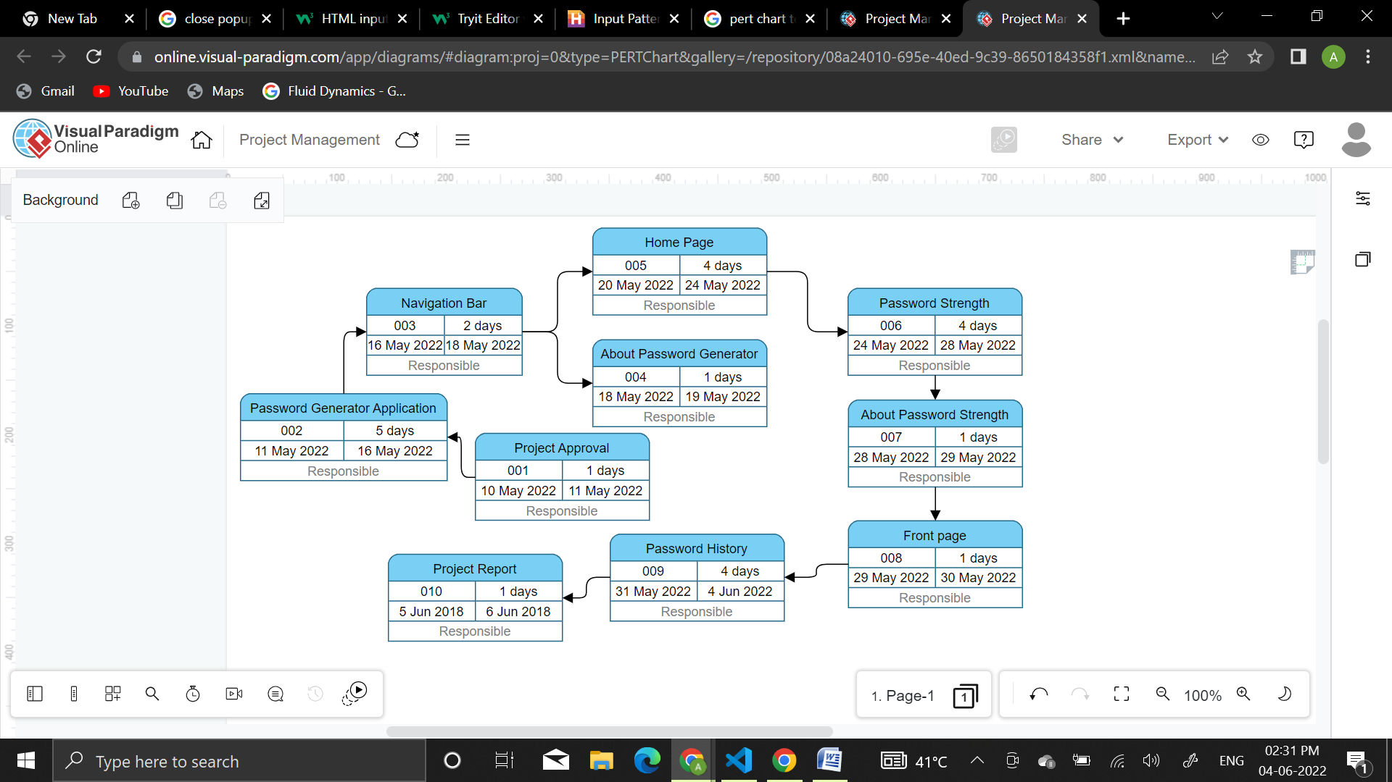

METHODOLOGY

**Data Flow Diagram**

A data flow diagram (DFD) maps out the flow of information for any process or system. It uses defined symbols like rectangles, circles and arrows, plus short text labels, to show data inputs, outputs, storage points and the routes between each destination. Data flowcharts can range from simple, even hand-drawn process overviews, to in-depth, multi-level DFDs that dig progressively deeper into how the data is handled. They can be used to analyze an existing system or model a new one. Like all the best diagrams and charts, a DFD can often visually “say” things that would be hard to explain in words, and they work for both technical and nontechnical audiences, from developer to CEO. That’s why DFDs remain so popular after all these years. While they work well for data flow software and systems, they are less applicable nowadays to visualizing interactive, real-time or database-oriented software or systems.

**History of Data Flow Diagram**

Data flow diagrams were popularized in the late 1970s, arising from the book *Structured Design*, by computing pioneers Ed Yourdon and Larry Constantine. They based it on the “data flow graph” computation models by David Martin and Gerald Estrin. The structured design concept took off in the software engineering field, and the DFD method took off with it. It became more popular in business circles, as it was applied to business analysis, than in academic circles.

Also contributing were two related concepts:

* Object Oriented Analysis and Design (OOAD), put forth by Yourdon and Peter Coad to analyze and design an application or system.
* Structured Systems Analysis and Design Method (SSADM), a waterfall method to analyze and design information systems. This rigorous documentation approach contrasts with modern agile approaches such as Scrum and Dynamic Systems Development Method (DSDM.)

Three other experts contributing to this rise in DFD methodology were Tom DeMarco, Chris Gane and Trish Sarson. They teamed up in different combinations to be the main definers of the symbols and notations used for a data flow diagram.

**ENTITY-RELATIONSHIP DIAGRAM**

An Entity Relationship (ER) Diagram is a type of flowchart that illustrates how “entities” such as people, objects or concepts relate to each other within a system. ER Diagrams are most often used to design or debug relational databases in the fields of software engineering, business information systems, education and research. Also known as ERDs or ER Models, they use a defined set of symbols such as rectangles, diamonds, ovals and connecting lines to depict the interconnectedness of entities, relationships and their attributes. They mirror grammatical structure, with entities as nouns and relationships as verbs.

ER diagrams are related to data structure diagrams (DSDs), which focus on the relationships of elements within entities instead of relationships between entities themselves. ER diagrams also are often used in conjunction with data flow diagrams (DFDs), which map out the flow of information for processes or systems

**History of ER Diagram**

Peter Chen (a.k.a. Peter Pin-Shan Chen), currently a faculty member at Carnegie-Mellon University in Pittsburgh, is credited with developing ER modeling for database design in the 1970s. While serving as an assistant professor at MIT’s Sloan School of Management, he published a seminal paper in 1976 titled “The Entity-Relationship Model: Toward a Unified View of Data.”

In a broader sense, the depiction of the interconnectedness of things dates back to least ancient Greece, with the works of Aristotle, Socrates and Plato. It’s seen more recently in the 19th and 20th Century  works of philosopher-logicians like Charles Sanders Peirce and Gottlob Frege.

By the 1960s and 1970s, Charles Bachman (above) and A.P.G. Brown were working with close predecessors of Chen’s approach.  Bachman developed a type of Data Structure Diagram, named after him as the Bachman Diagram. Brown published works on real-world systems modeling.  James Martin added ERD refinements. The work of Chen, Bachman, Brown, Martin and others also contributed to the development of Unified Modeling Language (UML), widely used in software design.

HARDWARE AND SOFTWARE TO BE USED

HARDWARE

* RAM : 8.00 GB
* PROCESSOR : Intel(R) Core(TM) i5-7200U CPU @ 2.50GHz 2.70 GHz

SOFTWARE

* VISUAL STUDIO
* GOOGLE CHROME/MICROSOFT EDGE
* OPERATING SYSTEM : WINDOWS 10
* Google spreadsheet

**SOFTWARE MAINTENANCE & EVALUATION**

This software work on with internet connection and it does not required maintenance.

DETAILED LIFE CYCLE OF THE PROJECT

* ENTITY-RELATIONSHIP DIAGRAM

Home page

**Password Strength**

Password Generate

**Password Generator Application**

Generate

Generator

Strength Checker

Copy

About

Contain

**Save Password**

Contain

Password History

Save

DATA FLOW DIAGRAM

HOME PAGE

FONT PAGE

A

Password History

PASSWORD STRENGTH

PASSWORD GENERATOR

ENTER/PASTE PASSWORD

Save password

Set length of password

Check strength of password

Email ID

INCLUDE UPPERCASE

STRONG

MEDIUM

WEAK

Generate password

Website

INCLUDE NUMBERS

Username

INCLUDE SYMBOLS

COPY TO CLIPBORD

Password

A

Save

FRONT-END SCREENSHORTS

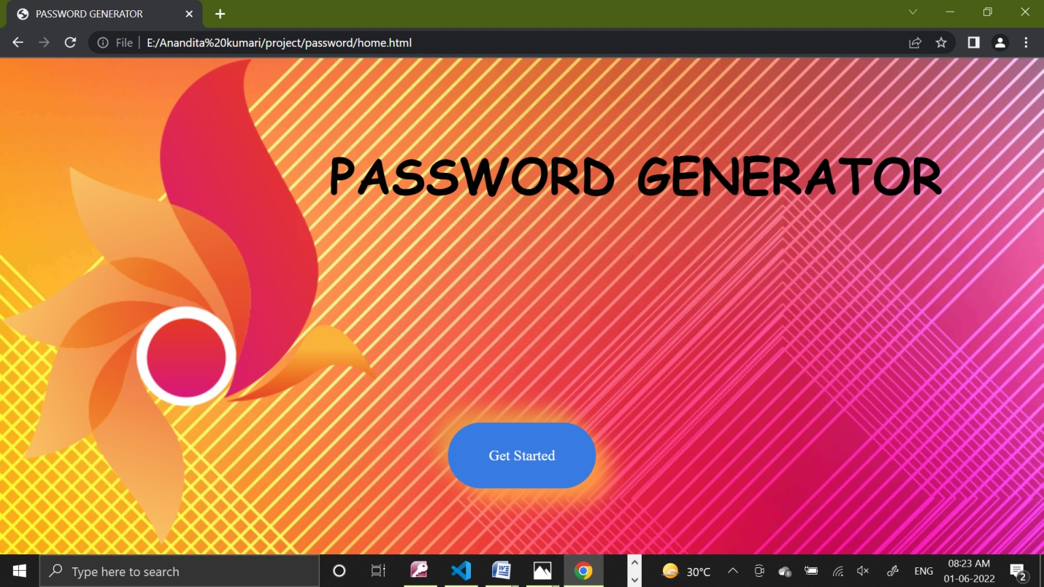

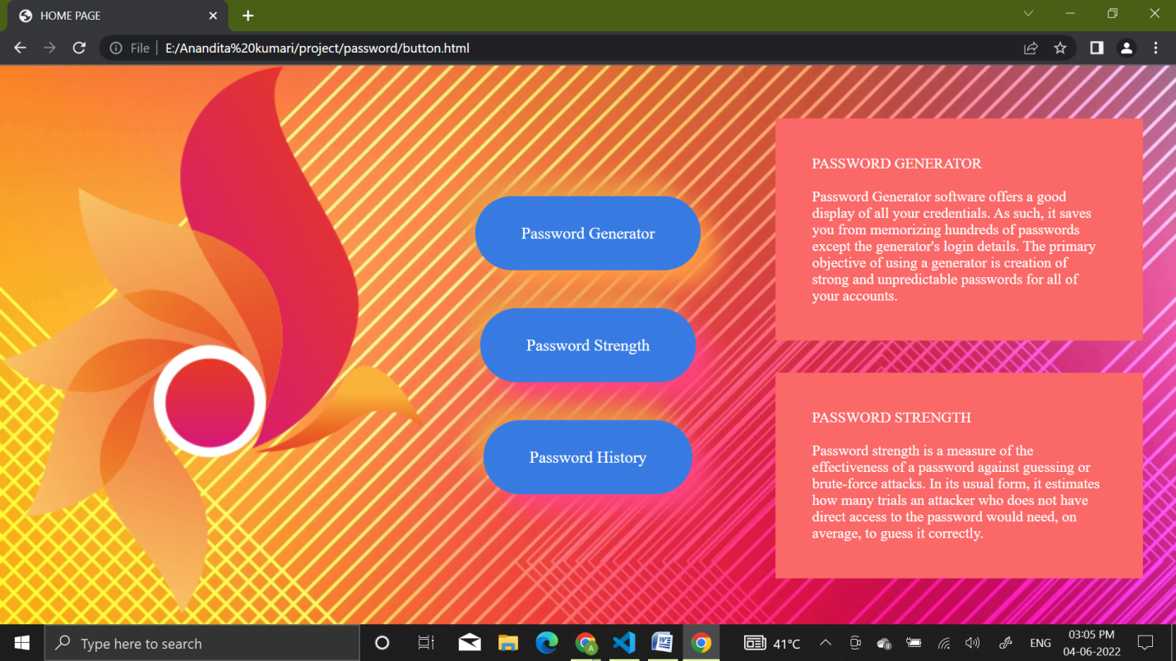

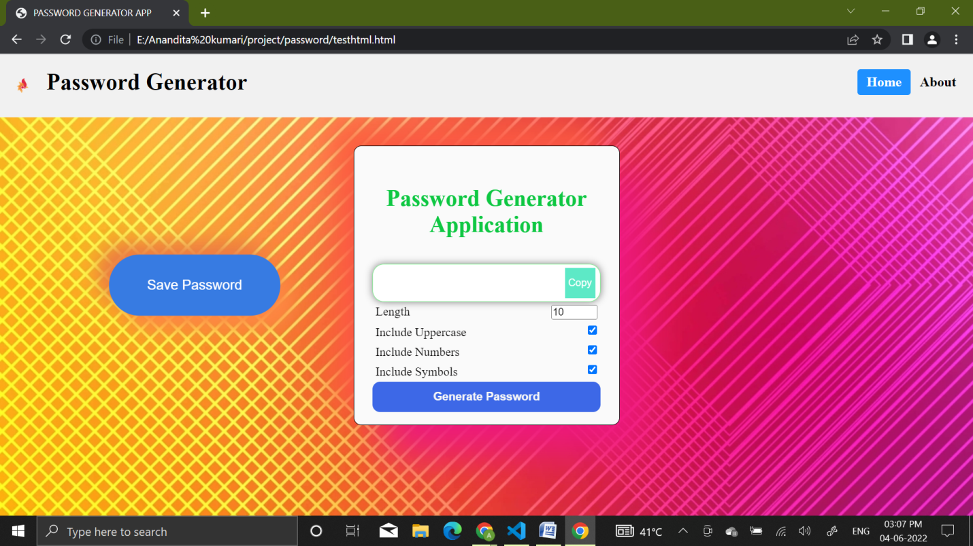

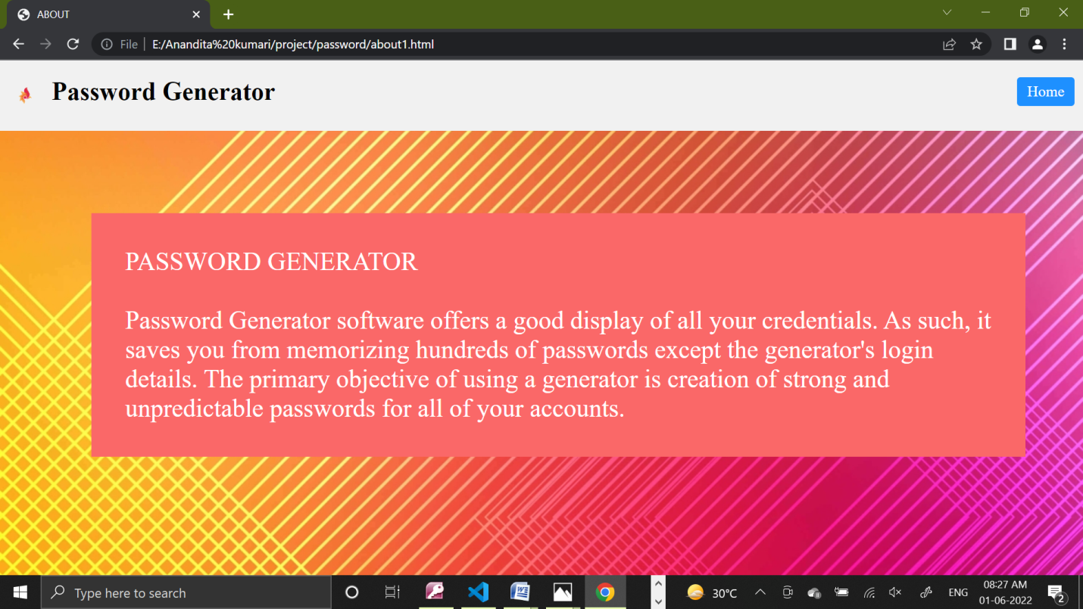

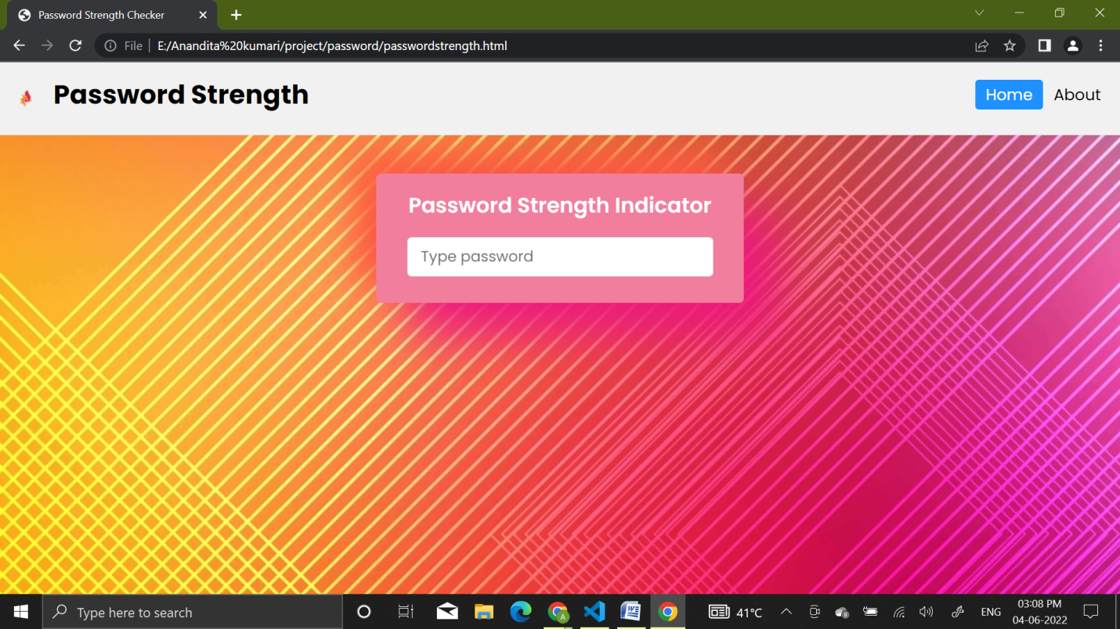

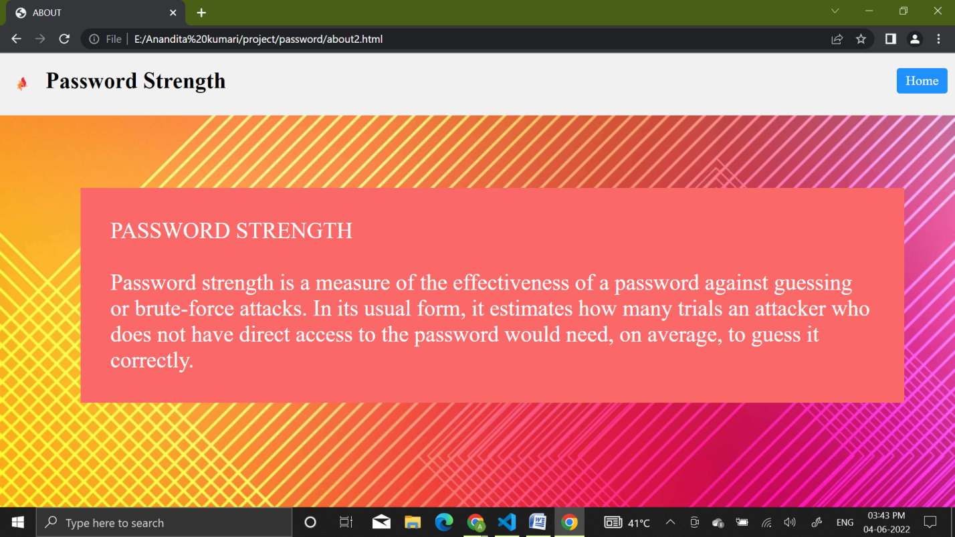

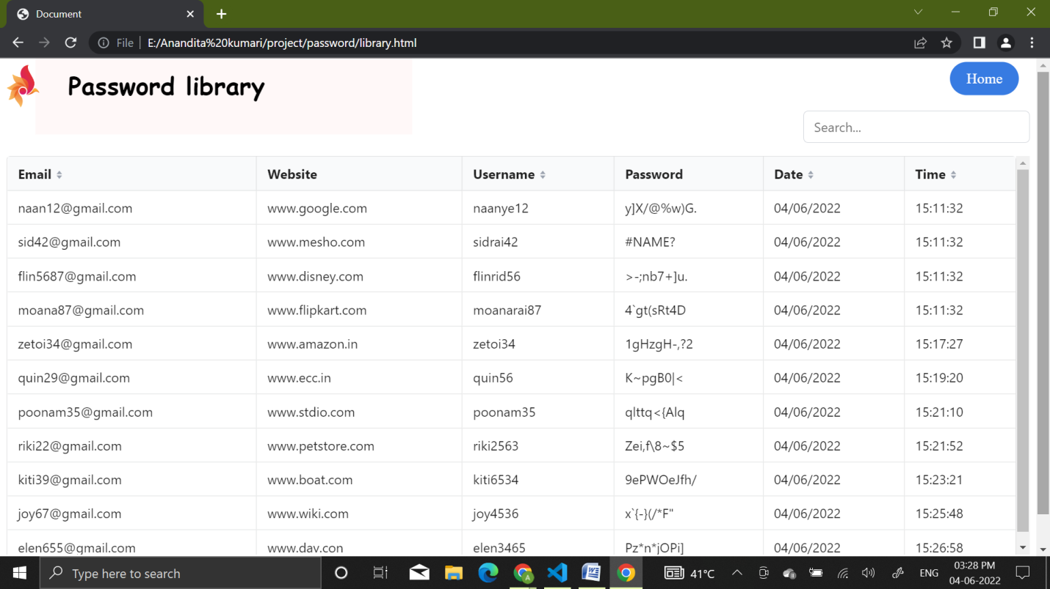

METHODOLOGY USED FOR TESTING

* WHITE BOX TESTING/BLACK BOX TESTING

In white box testing, the test is based on the knowledge of the internal logic of an application’s code. White box testing is sometimes known as glass box testing is based on requirements and functionality.

In Black box testing, the internal system design is not considered. The test performs in black box testing are based on requirements and functionality.

* ALPHA TESTING

Alpha testing is performed by the potential customer or independent test unit at the developer’s sits.

* BETA TESTING

This testing is done by the potential and/or existing customer at an external site not being involved with the developer’s. This is done to determine whether the component of the system specifies the customer needs and requirements.

* UNIT TESTING

Unit testing deals with the testing of individual software components or modules. The source code is used to be divided into modules, which is basically called units; the tests are done on these units and is called unit test. It depends upon the language on which the project=t is developed,

* ACCEPTANCE TESTING

Acceptance testing is done at user end. To test a product as to meet his specified requirements.

* COMPATIBILITY TESTING

Compatibility testing is the testing which is done to ensure the compatibility of an application or a website with different browsers, operating system and other hardware and software platform.

* FUNCTIONAL TESTING

Functional testing is the testing done to validate an application. A website to its specifications and correctly performs all its required functions.

* INTEGRATION TESTING

The testing in which the modules are combined with each other and testing as a group is known as integration testing. Integration testing follows unit testing and precedes system testing.

* RECOVERY TESTING

It tests how well the system recovers from crashes, hardware failure and software problem etc.

* SECURITY TESTING

Security testing checks the security of the application. In other words, it tests how well the system protects against unauthorized internal or external access. It also checks whether the system. Database is saved from external attack or not (such as hacking).

SOURCE CODE

* FRONT PAGE

<!DOCTYPE html>

<html lang="en">

<head>

    <meta charset="UTF-8">

    <meta http-equiv="X-UA-Compatible" content="IE=edge">

    <meta name="viewport" content="width=device-width, initial-scale=1.0">

    <title>PASSWORD GENERATOR</title>

    <style>

         body {

  background-image: url("abstract.jpg");

  font-family: raleway;

  color: white;

  margin: 0;

}

.button {

    color: white;

    font-size: 18px;

    font-weight: 500;

    padding: 30px 50px;

    border-radius: 40px;

    border: none;

    position: absolute;

    top: 80%;

    left: 50%;

    transform: translate(-50%, -50%);

    background: #377be2;

    box-shadow:  18px 18px 25px #fd9a43,

                 -15px -15px 25px #eb9a44;

    transition: box-shadow .35s ease !important;

    outline: none;

    /*text underline*/

    text-decoration: none;

}

.button:hover {

    background: linear-gradient(145deg, #489ceb, #89b9ed);

    box-shadow:  5px 5px 10px #41c7f0,

                 -5px -5px 10px #42a0f2;

    border: none;

}

P2{

    background-color: rgba(250, 104, 104, 0.048);

    width: 60%;

    /*position*/

    position: absolute;

    top: 20%;

    left: 60%;

    transform: translate(-50%, -50%);

    padding: 40px;

    margin: 20px;

    color: rgb(0, 0, 0);

    font-size: 60px;

    font-family: "comic sans ms";

    font-weight: bold;

}

P3{

    background-color: rgba(250, 104, 104, 0.048);

      width: 10%;

    /*position*/

    position: absolute;

    top: 30%;

    left: 62%;

    transform: translate(-50%, -50%);

    padding: 40px;

    margin: 20px;

    color: rgb(2, 2, 2);

    font-size: 60px;

    font-family: 'Gill Sans', 'Gill Sans MT', Calibri, 'Trebuchet MS', sans-serif;

    font-weight: bold;

}

P4{

    background-color: rgba(250, 104, 104, 0.048);

      width: 40%;

    /*position*/

    position: absolute;

    top: 40%;

    left: 67%;

    transform: translate(-50%, -50%);

    padding: 40px;

    margin: 20px;

    color: rgb(6, 6, 6);

    font-size: 60px;

    font-family: 'comic sans ms';

    font-weight: bold;

}

    </style>

</head>

<body>

        <!--code to make two button with same width -->

        <div class="bg-img">

            <!--code to add image-->

            <img src = "abstract flower.png" alt="abstract flower" width="36%" height="auto" >

        </div>

    <p2>PASSWORD GENERATOR</p2><P3></P3> <p4></p4>

        <div class="container">

             <a href="button.html" class="button">Get Started</a>

        </div>

</body>

</html>

* HOME PAGE

HTML CODE

<!DOCTYPE html>

<html lang="en">

<head>

    <meta charset="UTF-8">

    <meta http-equiv="X-UA-Compatible" content="IE=edge">

    <meta name="viewport" content="width=device-width, initial-scale=1.0">

    <!--link buttoncss.css-->

    <link rel="stylesheet" href="buttoncss.css">

    <title>HOME PAGE</title>

</head>

<body>

    <!--code to make two button with same width -->

    <div class="bg-img">

        <!--code to add image-->

        <img src = "abstract flower.png" alt="abstract flower" width="36%" height="auto" >

    </div>

    <div class="container">

         <a href="testhtml.html" class="signup-button">Password Generator</a>

        <a href="passwordstrength.html" class="login-button">Password Strength</a>

        <a href="library.html" class="manager-button">Password History</a>

    </div>

    <!--create box for text background-->

    <p>PASSWORD GENERATOR

    <br><br> Password Generator software offers a good

    display of all your credentials. As such, it saves

     you from memorizing hundreds of passwords except

     the generator's login details. The primary objective of

      using a generator is creation of strong and unpredictable

       passwords for all of your accounts.</P>

       <p1>PASSWORD STRENGTH

        <br><br> Password strength is a measure of the

        effectiveness of a password against guessing or

        brute-force attacks. In its usual form, it estimates

         how many trials an attacker who does not have direct

         access to the password would need, on average, to guess it correctly.</P1>

</body>

</html>

CSS CODE

/*code to style signup button*/

 body {

  background-image: url("abstract.jpg");

  font-family: raleway;

  color: white;

  margin: 0;

}

.signup-button {

    color: white;

    font-size: 18px;

    font-weight: 500;

    padding: 30px 50px;

    border-radius: 40px;

    border: none;

    position: absolute;

    top: 30%;

    left: 50%;

    transform: translate(-50%, -50%);

    background: #377be2;

    box-shadow:  18px 18px 25px #fd9a43,

                 -15px -15px 25px #eb9a44;

    transition: box-shadow .35s ease !important;

    outline: none;

    /*text underline*/

    text-decoration: none;

}

.signup-button:hover {

    background: linear-gradient(145deg, #489ceb, #89b9ed);

    box-shadow:  5px 5px 10px #41c7f0,

                 -5px -5px 10px #42a0f2;

    border: none;

}

/*style for the login button*/

.login-button {

    color: white;

    font-size: 18px;

    font-weight: 500;

    padding: 30px 50px;

    border-radius: 40px;

    border: none;

    position: absolute;

    top: 50%;

    left: 50%;

    transform: translate(-50%, -50%);

    background: #377be2;

    box-shadow:  18px 18px 25px #fd437e,

                 -15px -15px 25px #eb9a44;

    transition: box-shadow .35s ease !important;

    outline: none;

    text-decoration: none;

}

.login-button:hover {

    background: linear-gradient(145deg, #489ceb, #89b9ed);

    box-shadow:  5px 5px 10px #41c7f0,

                 -5px -5px 10px #42a0f2;

    border: none;

}

/*manager style*/

.manager-button {

    color: white;

    font-size: 18px;

    font-weight: 500;

    padding: 30px 50px;

    border-radius: 40px;

    border: none;

    position: absolute;

    top: 70%;

    left: 50%;

    transform: translate(-50%, -50%);

    background: #377be2;

    box-shadow:  18px 18px 25px #fd437e,

                 -15px -15px 25px #eb9a44;

    transition: box-shadow .35s ease !important;

    outline: none;

    text-decoration: none;

}

.manager-button:hover {

    background: linear-gradient(145deg, #489ceb, #89b9ed);

    box-shadow:  5px 5px 10px #41c7f0,

                 -5px -5px 10px #42a0f2;

    border: none;

}

/*position of image*/

p{

    background-color: rgb(250, 104, 104);

    width: 25%;

    /*position*/

    position: absolute;

    top: 26%;

    left: 80%;

    transform: translate(-50%, -50%);

    padding: 40px;

    margin: 20px;

  }

  p1{

    background-color: rgb(250, 104, 104);

    width: 25%;

    /*position*/

    position: absolute;

    top: 70%;

    left: 80%;

    transform: translate(-50%, -50%);

    padding: 40px;

    margin: 20px;

  }

* PASSWORD GENERATOR APLLICATION

HTML CODE

<!DOCTYPE html>

<html lang="en">

  <head>

    <title>PASSWORD GENERATOR APP</title>

    <link rel="stylesheet" href="layout.css" />

    <script src="javascpassword.js" defer></script>

   </head>

  <body>

    <div class="header">

      <!--logoimage image-->

      <a>

        <img src="abstract flower.png" alt="logo" style="width:15px;height:auto;">

        </a>

      <a href="#default" class="logo">Password Generator</a>

      <div class="header-right">

        <a class="active" href="button.html">Home</a>

        <!--<a href="#contact">Contact</a>-->

        <a href="about1.html">About</a>

      </div>

    </div>

</body>

<body>

    <form id="passwordGeneratorForm">

      <div class="container">

        <h2>Password Generator Application</h2>

        <div class="result__container">

        <span id="result"></span>

        <button id="copy">Copy</button>

      </div>

      <div class="options">

        <div class="option">

          <label>Length</label>

          <input type="number" id="length" min="4" max="20" value="10">

        </div>

        <div class="option">

          <label>Include Uppercase</label>

          <input type="checkbox" id="uppercase" checked>

        </div>

        <div class="option">

          <label>Include Numbers</label>

          <input type="checkbox" id="numbers" checked>

        </div>

        <div class="option">

          <label>Include Symbols</label>

          <input type="checkbox" id="symbols" checked>

        </div>

      </div>

      <button class="btn" id="generate" type="submit">Generate Password</button>

      </div>

    </form>

      <div class="popup" id="popup-1" name="popup">

        <div class="content">

         <div class="close-btn" onclick="togglePopup()">

          ×</div>

     <h1>Save Password</h1>

     <form id="savePasswordForm" name="savePassword" >

     <div type="text" name="Email" class="input-field"><input type="email" name="Email" placeholder="Email" class="validate" required ></div>

       <div type="text" name="Website" class="input-field"><input type="website" name="Website" placeholder="website" class="validate" required pattern="www.+" title="www.example.com"></div>

       <div type="text" name="Username" class="input-field"><input name="Username" placeholder="username" class="validate" required pattern="[a-zA-Z0-9]+" title="Only letters and numbers"></div>

       <div type="password" name="Password"class="input-field"><input name="Password" type="password" placeholder="Password" class="validate" required></div>

       <input name="Date" type="hidden" id="currentDate" >

    <input name="Time" type="hidden" id="currentTime" >

         <button type="submit" id="submit" class="second-button"  onclick="checkPattern()" >Save</button>

        </div>

       </div>

         </div>

      </form>

  <button onclick="togglePopup(), clearForm()" class="first-button">Save Password</button>

     </body>

</html>

<script>

  const scriptURL = 'https://script.google.com/macros/s/AKfycbxO_nkJcMZilvfQQnrjkqW2ZEzeMR_wctkR7K75GT_hJfT6GJImRrjQLOpbk3Sn31z4/exec'

  //popup function

  function togglePopup() {

    const popup = document.querySelector('.popup')

    popup.classList.toggle('active')

  }

   const form = document.forms['savePassword']

  form.addEventListener('submit', e => {

    e.preventDefault()

    fetch(scriptURL, { method: 'POST', body: new FormData(form)})

      .then(response => console.log('Success!', response))

      .catch(error => console.error('Error!', error.message))

  })

var today1 = new Date();

var time = today1.getHours() + ":" + today1.getMinutes() + ":" + today1.getSeconds();

  document.getElementById("currentTime").value = time;

var today = new Date();

var date = today.getDate()+'/'+(today.getMonth()+1)+'/'+today.getFullYear();

  document.getElementById("currentDate").value = date;

  //close popup function when click on sumbit button

  function closePopup() {

    togglePopup()

  }

//clear form on click on save password button

function clearForm() {

document.getElementById("savePasswordForm").reset();

}

//delay alert after click submit button and show alert if it is conncted to internet

function delayAlert() {

  setTimeout(function() {

    if (navigator.onLine) {

      alert("Password saved successfully");

    } else {

      alert("Please connect to internet, password not saved");

    }

  }, 100);

}

//close popup if submit button is click and if form contain correct pattern

function checkPattern() {

  if (document.getElementById("savePasswordForm").checkValidity()) {

    closePopup()

    delayAlert()

  }

}

</script>

CSS CODE

* {

    margin: 0;

    padding: 0;

    box-sizing: border-box;

  }

   h2{

     color: rgb(14, 199, 66);

     /*code to make style */

      font-size: 30px;

      font-weight: bold;

      text-align: center;

      margin-top: 20px;

      margin-bottom: 20px;

   }

 body {

    height: 100vh;

    width: 100vw;

    display: flex;

    align-items: center;

    justify-content: center;

    flex-direction: column;

    /*font-family: 'Roboto', sans-serif; */

 /* set wallpaper of technical page */

    background-image: url('abstract.jpg');

    font-family: raleway;

        color: rgb(7, 6, 6);

        margin: 0;

    background-repeat: no-repeat;

    background-position: left;

    background-attachment: fixed;

    /*background-color: #a3a2f9;*/

  }

  .container {

    padding: 1rem 1.5rem;

    border: 1px solid black;

    width: 350px;

    /*code for glossy effect*/

    border-radius: 10px;

    background-color: #fafafa;

  box-shadow: 38px 38px 56px #ed187f,

  -25px -25px 38px #fc5e3e;

    /*background-color: #b9f383;*/

  }

  h2 {

    text-align: center;

    padding: 15px 0;

  }

  .option {

    display: flex;

    justify-content: space-between;

    padding: 4px;

  }

  .result__container {

    height: 50px;

    width: 100%;

    display: flex;

    justify-content: space-between;

    align-items: center;

    /*code to make glass boundry */

    box-shadow: 0px 0px 10px rgba(0, 0, 0, 0.5);

    border-radius: 15px;

    background-color: #ffffff;

    border: 1px solid rgb(129, 245, 145);

    padding: 0 6px;

  }

  .result-container #result {

    word-wrap: break-word;

    max-width: calc(100% - 40px);

  }

  .result__container #copy {

    height: 40px;

    width: 40px;

    background-color: #5de9c6;

    color: #ffffff;

    border: none;

    cursor: pointer;

    outline: none;

  }

  .result__container #copy:hover {

    background-color: #40ce80;

    color: #ffffff;

  }

  #generate {

    height: 40px;

    width: 100%;

    border-radius: 10px;

    border: none;

    background-color: #3d68e7;

    color: #f6f6f6;

    font-size: 15px;

    font-weight: bold;

    cursor: pointer;

    outline: none;

  }

  #generate:hover {

    background-color: #5bc0be;

    color: #ffffff;

  }

/* Style the header with a grey background and some padding */

.header {

  overflow: hidden;

  background-color: #f1f1f1;

  padding: 20px 10px;

  /*position on top of the page*/

  position: fixed;

  top: 0;

  left: 0;

  right: 0;

  z-index: 1;

}

/* Style the header links */

.header a {

  float: left;

  color: black;

  text-align: center;

  padding: 12px;

  text-decoration: none;

  font-size: 18px;

  line-height: 10px;

  border-radius: 4px;

}

/* Style the logo link (notice that we set the same value of line-height and font-size to prevent the header to increase when the font gets bigger */

.header a.logo {

  font-size: 30px;

  font-weight: bold;

}

/* Change the background color on mouse-over */

.header a:hover {

  background-color: #ddd;

  color: black;

}

/* Style the active/current link*/

.header a.active {

  background-color: dodgerblue;

  color: white;

}

/* Float the link section to the right */

.header-right {

  float: right;

}

/* Add media queries for responsiveness - when the screen is 500px wide or less, stack the links on top of each other */

@media screen and (max-width: 500px) {

  .header a {

    float: none;

    display: block;

    text-align: left;

  }

  .header-right {

    float: none;

  }

}

.popup .content {

 position: absolute;

 top: 50%;

 left: 50%;

 transform: translate(-50%,-150%) scale(0);

 width: 340px;

 height: 490px;

 z-index: 2;

 text-align: center;

 padding: 20px;

 border-radius: 20px;

 background: #7e8bf1;

 box-shadow:  38px 38px 56px #1b18ed,

             -25px -25px 38px #5452e8;

 z-index: 1;

}

.popup .close-btn {

 position: absolute;

 right: 15px;

 top: 20px;

 width: 35px;

 height: 35px;

 color: white;

 font-size: 30px;

 border-radius: 50%;

 padding: 2px 5px 7px 5px;

 background: #3f64ec;

 box-shadow:  5px 5px 15px #4667ec,

             -5px -5px 15px #8899e7;

 }

.popup.active .content {

transition: all 300ms ease-in-out;

transform: translate(-50%,-50%) scale(1);

}

h1 {

 text-align: center;

 font-size: 32px;

 font-weight: 600;

 padding-top: 20px;

 padding-bottom: 10px;

}

a {

 font-weight: 600;

 color: white;

}

.input-field .validate {

padding: 20px;

font-size: 16px;

border-radius: 10px;

border: none;

margin-bottom: 15px;

color: #080808;

background: #f8f8f8;

box-shadow: inset 5px 5px 5px #5d5dfc,

            inset -5px -5px 5px #6b4def;

outline: none;

}

.first-button {

color: white;

font-size: 18px;

font-weight: 500;

padding: 30px 50px;

border-radius: 40px;

border: none;

position: absolute;

top: 50%;

left: 20%;

transform: translate(-50%, -50%);

background: #377be2;

box-shadow:  18px 18px 25px #fd8743,

             -15px -15px 25px #eb7944;

transition: box-shadow .35s ease !important;

outline: none;

}

.first-button:active {

background: linear-gradient(145deg, #4853eb, #89b9ed);

box-shadow:  5px 5px 10px #4155f0,

             -5px -5px 10px #424ef2;

border: none;

}

.second-button {

color: white;

font-size: 18px;

font-weight: 500;

margin-top: 20px;

padding: 20px 30px;

border-radius: 40px;

border: none;

background: #4b64f4;

box-shadow:  8px 8px 15px #4062fc,

             -8px -8px 15px #1e23be;

transition: box-shadow .35s ease !important;

outline: none;

}

.second-button:active{

background: linear-gradient(145deg,#303edc, #3229dd);

box-shadow: 5px 5px 10px #5350f8, -5px -5px 10px #4284da;

border: none;

outline: none;

}

p{

color: #ebf1f1;

padding: 20px;

}

/*styl class for fogo

JAVASCRIPT CODE

// Getting the DOM Elements

const resultDOM = document.getElementById("result");

const copybtnDOM = document.getElementById("copy");

const lengthDOM = document.getElementById("length");

const uppercaseDOM = document.getElementById("uppercase");

const numbersDOM = document.getElementById("numbers");

const symbolsDOM = document.getElementById("symbols");

const generatebtn = document.getElementById("generate");

const form1 = document.getElementById("passwordGeneratorForm");

//save button dom element

const savebtn = document.getElementById("save");

// Generating Character Codes For The Application

const UPPERCASE_CODES = arrayFromLowToHigh(65, 90);

const LOWERCASE_CODES = arrayFromLowToHigh(97, 122);

const NUMBER_CODES = arrayFromLowToHigh(48, 57);

const SYMBOL_CODES = arrayFromLowToHigh(33, 47)

  .concat(arrayFromLowToHigh(58, 64))

  .concat(arrayFromLowToHigh(91, 96))

  .concat(arrayFromLowToHigh(123, 126));

  // Character Code Generating Function

function arrayFromLowToHigh(low, high) {

    const array = [];

    for (let i = low; i <= high; i++) {

      array.push(i);

    }

    return array;

  }

  // The Password Generating Function

let generatePassword = (

    characterAmount,

    includeUppercase,

    includeNumbers,

    includeSymbols

  ) => {

    let charCodes = LOWERCASE_CODES;

    if (includeUppercase) charCodes = charCodes.concat(UPPERCASE_CODES);

    if (includeSymbols) charCodes = charCodes.concat(SYMBOL_CODES);

    if (includeNumbers) charCodes = charCodes.concat(NUMBER_CODES);

    const passwordCharacters = [];

    for (let i = 0; i < characterAmount; i++) {

      const characterCode =

        charCodes[Math.floor(Math.random() * charCodes.length)];

      passwordCharacters.push(String.fromCharCode(characterCode));

    }

    return passwordCharacters.join("");

  }

  // Copy password button

  // Checking the options that are selected and setting the password

form1.addEventListener("submit", (e) => {

    e.preventDefault();

    const characterAmount = lengthDOM.value;

    const includeUppercase = uppercaseDOM.checked;

    const includeNumbers = numbersDOM.checked;

    const includeSymbols = symbolsDOM.checked;

    const password = generatePassword(

      characterAmount,

      includeUppercase,

      includeNumbers,

      includeSymbols

    );

    resultDOM.innerText = password;

  });

/* Toggle between adding and removing the "responsive" class to topnav when the user clicks on the icon */

function myFunction() {

  var x = document.getElementById("myTopnav");

  if (x.className === "topnav") {

    x.className += " responsive";

  } else {

    x.className = "topnav";

  }

}

function togglePopup() {

  document.getElementById("popup-1")

   .classList.toggle("active");

 }

 copybtnDOM.addEventListener("click", (e) => {

  e.preventDefault();

  const textarea = document.createElement("textarea");

  const passwordToCopy = resultDOM.innerText;

  // A Case when Password is Empty

  if (passwordToCopy === "") {

    alert("Please Generate a Password First");

  } else {

  //Copy Functionality

  textarea.value = passwordToCopy;

  document.body.appendChild(textarea);

  textarea.select();

  document.execCommand("copy");

  textarea.remove();

  alert("Password Copied to Clipboard");

  }

});

* ABOUT PASSWORD GENERATOR

<!DOCTYPE html>

<html lang="en">

<head>

    <meta charset="UTF-8">

    <meta http-equiv="X-UA-Compatible" content="IE=edge">

    <meta name="viewport" content="width=device-width, initial-scale=1.0">

    <title>ABOUT</title>

    <style>

        p1{

    background-color: rgb(250, 104, 104);

    width: 80%;

    /*position*/

    position: absolute;

    top: 50%;

    left: 50%;

    transform: translate(-50%, -50%);

    padding: 40px;

    margin: 20px;

    color: rgb(255, 255, 255);

    font-size: 30px;

  }

    </style>

          <style> body {

            background-image: url("abstract.jpg");

            font-family: raleway;

            color: rgb(7, 6, 6);

            margin: 0;

          }

            /* Style the header with a grey background and some padding */

.header {

  overflow: hidden;

  background-color: #f1f1f1;

  padding: 20px 10px;

  /*position on top of the page*/

  position: fixed;

  top: 0;

  left: 0;

  right: 0;

  z-index: 1;

}

/* Style the header links */

.header a {

  float: left;

  color: black;

  text-align: center;

  padding: 12px;

  text-decoration: none;

  font-size: 18px;

  line-height: 10px;

  border-radius: 4px;

}

/* Style the logo link (notice that we set the same value of line-height and font-size to prevent the header to increase when the font gets bigger */

.header a.logo {

  font-size: 30px;

  font-weight: bold;

}

/* Change the background color on mouse-over */

.header a:hover {

  background-color: #ddd;

  color: black;

}

/* Style the active/current link*/

.header a.active {

  background-color: dodgerblue;

  color: white;

}

/* Float the link section to the right */

.header-right {

  float: right;

}

/* Add media queries for responsiveness - when the screen is 500px wide or less, stack the links on top of each other */

@media screen and (max-width: 500px) {

  .header a {

    float: none;

    display: block;

    text-align: left;

  }

  .header-right {

    float: none;

  }

}

          </style>

</head>

<body>

    <div class="bg-img">

        <p1>PASSWORD GENERATOR

            <br><br> Password Generator software offers a good

            display of all your credentials. As such, it saves

             you from memorizing hundreds of passwords except

             the generator's login details. The primary objective of

              using a generator is creation of strong and unpredictable

               passwords for all of your accounts.</P1>

    </div>

    <body>

        <div class="header">

          <!--logoimage image-->

          <a>

            <img src="abstract flower.png" alt="logo" style="width:15px;height:auto;">

          </a>

          <a href="#default" class="logo">Password Generator</a>

          <div class="header-right">

            <a class="active" href="button.html">Home</a>

          </div>

        </div>

    </body>

</body>

</html>

* PASSWORD STRENGTH

HTML,CSS,JAVASCRIPT CODE

<!DOCTYPE html>

<html lang="en" dir="ltr">

   <head>

      <meta charset="utf-8">

      <title>Password Strength Checker</title>

      <link rel="stylesheet" href="strengthcss.css">

      <style> body {

        background-image: url("abstract.jpg");

        font-family: raleway;

        color: rgb(7, 6, 6);

        margin: 0;

      }

      </style>

   </head>

   <body>

    <div class="header">

      <!--logoimage image-->

      <a>

        <img src="abstract flower.png" alt="logo" style="width:15px;height:auto;">

      </a>

      <a href="#default" class="logo">Password Generator</a>

      <div class="header-right">

        <a class="active" href="button.html">Home</a>

        <!--<a href="#contact">Contact</a>-->

        <a href="about2.html">About</a>

      </div>

    </div>

</body>

   <body>

    <div class="bg-img">

      <div class="container">

         <header style="color:#ffffff;">Password Strength Indicator <br></header>

         <form action="#">

            <div class="field">

               <input onkeyup="trigger()" type="password" placeholder="Type password">

               <span class="showBtn">SHOW</span>

            </div>

            <div class="indicator">

               <span class="weak"></span>

               <span class="medium"></span>

               <span class="strong"></span>

            </div>

            <div class="text"></div>

         </form>

      </div>

      <script>

         const indicator = document.querySelector(".indicator");

         const input = document.querySelector("input");

         const weak = document.querySelector(".weak");

         const medium = document.querySelector(".medium");

         const strong = document.querySelector(".strong");

         const text = document.querySelector(".text");

         const showBtn = document.querySelector(".showBtn");

         let regExpWeak = /[a-z]/;

         let regExpMedium = /\d+/;

         let regExpStrong = /.[!,@,#,$,%,^,&,*,?,_,~,-,(,)]/;

         function trigger(){

           if(input.value != ""){

             indicator.style.display = "block";

             indicator.style.display = "flex";

             if(input.value.length <= 3 && (input.value.match(regExpWeak) || input.value.match(regExpMedium) || input.value.match(regExpStrong)))no=1;

             if(input.value.length >= 6 && ((input.value.match(regExpWeak) && input.value.match(regExpMedium)) || (input.value.match(regExpMedium) && input.value.match(regExpStrong)) || (input.value.match(regExpWeak) && input.value.match(regExpStrong))))no=2;

             if(input.value.length >= 6 && input.value.match(regExpWeak) && input.value.match(regExpMedium) && input.value.match(regExpStrong))no=3;

             if(no==1){

               weak.classList.add("active");

               text.style.display = "block";

               text.textContent = "Your password is too week";

               text.classList.add("weak");

             }

             if(no==2){

               medium.classList.add("active");

               text.textContent = "Your password is medium";

               text.classList.add("medium");

             }else{

               medium.classList.remove("active");

               text.classList.remove("medium");

             }

             if(no==3){

               weak.classList.add("active");

               medium.classList.add("active");

               strong.classList.add("active");

               text.textContent = "Your password is strong";

               text.classList.add("strong");

             }else{

               strong.classList.remove("active");

               text.classList.remove("strong");

             }

             showBtn.style.display = "block";

             showBtn.onclick = function(){

               if(input.type == "password"){

                 input.type = "text";

                 showBtn.textContent = "HIDE";

                 showBtn.style.color = "#ef4d70";

               }else{

                 input.type = "password";

                 showBtn.textContent = "SHOW";

                 showBtn.style.color = "#000";

               }

             }

           }else{

             indicator.style.display = "none";

             text.style.display = "none";

             showBtn.style.display = "none";

           }

         }

      </script>

   </body>

</html>

CSS CODE

@import url('https://fonts.googleapis.com/css?family=Poppins:400,500,600,700&display=swap');

*{

  margin: 0;

  padding: 0;

  box-sizing: border-box;

  font-family: 'Poppins', sans-serif;

}

html,body{

  display: fullscreen;

  height: 100%;

  place-items: center;

  text-align: center;

  background: #f2f2f2;

}

.container{

    /*posiion*/

    position: absolute;

    top: 33%;

    left: 50%;

    transform: translate(-50%,-50%);

  background: #f17e9d;

  padding: 20px 30px;

  width: 420px;

  border-radius: 5px;

  box-shadow: 38px 38px 56px #ed187f,

  -25px -25px 38px #fc5e3e;

}

.container header{

  font-size: 24px;

  font-weight: 600;

  line-height: 33px;

}

.container form{

  margin: 20px 5px 10px 5px;

  position: relative;

}

.container form .field{

  height: 45px;

  width: 100%;

  display: flex;

  position: relative;

}

form .field input{

  width: 100%;

  height: 100%;

  border: 1px solid lightgrey;

  padding-left: 15px;

  outline: none;

  border-radius: 5px;

  font-size: 17px;

  transition: all 0.3s;

}

form .field input:focus{

  border-color: #ae2766;

  box-shadow: inset 0 0 3px #d02fa2;

}

form .field .showBtn{

  position: absolute;

  right: 10px;

  top: 50%;

  transform: translateY(-50%);

  font-size: 15px;

  font-weight: 600;

  cursor: pointer;

  display: none;

  user-select: none;

}

form .indicator{

  height: 10px;

  margin: 10px 0;

  display: flex;

  align-items: center;

  justify-content: space-between;

  display: none;

}

form .indicator span{

  position: relative;

  height: 100%;

  width: 100%;

  background: rgb(255, 255, 255);

  border-radius: 5px;

}

form .indicator span:nth-child(2){

  margin: 0 3px;

}

form .indicator span.active:before{

  position: absolute;

  content: '';

  top: 0;

  left: 0;

  height: 100%;

  width: 100%;

  border-radius: 5px;

}

.indicator span.weak:before{

  background-color:  #ff4757;

}

.indicator span.medium:before{

  background-color: orange;

}

.indicator span.strong:before{

  background-color: #01d459;

}

form .text{

  font-size: 20px;

  font-weight: 500;

  display: none;

  margin-bottom: -10px;

}

form .text.weak{

  color: #ffffff;

}

form .text.medium{

  color: rgb(255, 255, 255);

}

form .text.strong{

  color: #ffffff;

}

p1{

    background-color: rgb(250, 104, 104);

    width: 40%;

    /*position*/

    position: absolute;

    top: 70%;

    left: 50%;

    transform: translate(-50%, -50%);

    padding: 40px;

    margin: 20px;

    color: rgb(255, 255, 255);

  }

  /* Style the header with a grey background and some padding */

.header {

  overflow: hidden;

  background-color: #f1f1f1;

  padding: 20px 10px;

  /*position on top of the page*/

  position: fixed;

  top: 0;

  left: 0;

  right: 0;

  z-index: 1;

}

/* Style the header links */

.header a {

  float: left;

  color: black;

  text-align: center;

  padding: 12px;

  text-decoration: none;

  font-size: 18px;

  line-height: 10px;

  border-radius: 4px;

}

/* Style the logo link (notice that we set the same value of line-height and font-size to prevent the header to increase when the font gets bigger */

.header a.logo {

  font-size: 30px;

  font-weight: bold;

}

/* Change the background color on mouse-over */

.header a:hover {

  background-color: #ddd;

  color: black;

}

/* Style the active/current link*/

.header a.active {

  background-color: dodgerblue;

  color: white;

}

/* Float the link section to the right */

.header-right {

  float: right;

}

/* Add media queries for responsiveness - when the screen is 500px wide or less, stack the links on top of each other */

@media screen and (max-width: 500px) {

  .header a {

    float: none;

    display: block;

    text-align: left;

  }

  .header-right {

    float: none;

  }

}

* ABOUT PASSWORD STRENGTH

<!DOCTYPE html>

<html lang="en">

<head>

    <meta charset="UTF-8">

    <meta http-equiv="X-UA-Compatible" content="IE=edge">

    <meta name="viewport" content="width=device-width, initial-scale=1.0">

    <title>ABOUT</title>

    <style>

        p1{

    background-color: rgb(250, 104, 104);

    width: 80%;

    /*position*/

    position: absolute;

    top: 50%;

    left: 50%;

    transform: translate(-50%, -50%);

    padding: 40px;

    margin: 20px;

    color: rgb(255, 255, 255);

    font-size: 30px;

  }

    </style>

          <style> body {

            background-image: url("abstract.jpg");

            font-family: raleway;

            color: rgb(7, 6, 6);

            margin: 0;

          }

            /* Style the header with a grey background and some padding */

.header {

  overflow: hidden;

  background-color: #f1f1f1;

  padding: 20px 10px;

  /*position on top of the page*/

  position: fixed;

  top: 0;

  left: 0;

  right: 0;

  z-index: 1;

}

/* Style the header links */

.header a {

  float: left;

  color: black;

  text-align: center;

  padding: 12px;

  text-decoration: none;

  font-size: 18px;

  line-height: 10px;

  border-radius: 4px;

}

/* Style the logo link (notice that we set the same value of line-height and font-size to prevent the header to increase when the font gets bigger */

.header a.logo {

  font-size: 30px;

  font-weight: bold;

}

/* Change the background color on mouse-over */

.header a:hover {

  background-color: #ddd;

  color: black;

}

/* Style the active/current link*/

.header a.active {

  background-color: dodgerblue;

  color: white;

}

/* Float the link section to the right */

.header-right {

  float: right;

}

/* Add media queries for responsiveness - when the screen is 500px wide or less, stack the links on top of each other */

@media screen and (max-width: 500px) {

  .header a {

    float: none;

    display: block;

    text-align: left;

  }

  .header-right {

    float: none;

  }

}

          </style>

</head>

<body>

    <div class="bg-img">

    <p1>PASSWORD STRENGTH

        <br><br> Password strength is a measure of the

        effectiveness of a password against guessing or

        brute-force attacks. In its usual form, it estimates

         how many trials an attacker who does not have direct

         access to the password would need, on average, to guess it correctly.</P1>

    </div>

    <body>

        <div class="header">

          <!--logoimage image-->

          <a>

            <img src="abstract flower.png" alt="logo" style="width:15px;height:auto;">

          </a>

          <a href="#default" class="logo">Password Generator</a>

          <div class="header-right">

            <a class="active" href="button.html">Home</a>

          </div>

        </div>

    </body>

</body>

</html>

* PASSWORD HISTORY

<!DOCTYPE html>

<html lang="en">

<head>

    <meta charset="UTF-8">

    <meta http-equiv="X-UA-Compatible" content="IE=edge">

    <meta name="viewport" content="width=device-width, initial-scale=1.0">

    <title>Document</title>

    <style>

     .active {

    color: white;

    font-size: 18px;

    font-weight: 500;

    padding: 10px 20px;

    border-radius: 40px;

    border: none;

    position: absolute;

    top: 4%;

    left: 95%;

    transform: translate(-50%, -50%);

    background: #377be2;

    outline: none;

    /*text underline*/

    text-decoration: none;

}

.active:hover {

    background: linear-gradient(145deg, #489ceb, #89b9ed);

    box-shadow:  5px 5px 10px #41c7f0,

                 -5px -5px 10px #42a0f2;

    border: none;

}

p{

    background-color: rgba(250, 104, 104, 0.048);

    width: 30%;

    /*position*/

    position: absolute;

    top: 2%;

    left: 20%;

    transform: translate(-50%, -50%);

    padding: 40px;

    margin: 20px;

    color: rgb(0, 0, 0);

    font-size: 30px;

    font-family: "comic sans ms";

    font-weight: bold;

}

                    </style>

</head>

<body>

    <div class="container">

        <a class="active" href="button.html">Home</a>

        <p>Password library</p>

        <a>

            <img src="abstract flower.png" alt="logo" style="width:40px;height:auto;">

          </a>

   </div>

</body>

</html>

<!--notify user if it is not connected to the internet-->

<script>

    if(!navigator.onLine){

        alert("You are offline. Please connect to the internet.");

    }

</script>

<script src="https://sheetdb.io/s/t/q2brsvl4l14qh.js"></script>

* DATABASE SOURCE CODE

TABLE CODE

var sheetName = 'Sheet1'

var scriptProp = PropertiesService.getScriptProperties()

function intialSetup () {

  var activeSpreadsheet = SpreadsheetApp.getActiveSpreadsheet()

  scriptProp.setProperty('key', activeSpreadsheet.getId())

}

function doPost (e) {

  var lock = LockService.getScriptLock()

  lock.tryLock(10000)

  try {

    var doc = SpreadsheetApp.openById(scriptProp.getProperty('key'))

    var sheet = doc.getSheetByName(sheetName)

    var headers = sheet.getRange(1, 1, 1, sheet.getLastColumn()).getValues()[0]

    var nextRow = sheet.getLastRow() + 1

    var newRow = headers.map(function(header) {

      return header === 'timestamp' ? new Date() : e.parameter[header]

    })

    sheet.getRange(nextRow, 1, 1, newRow.length).setValues([newRow])

    return ContentService

      .createTextOutput(JSON.stringify({ 'result': 'success', 'row': nextRow }))

      .setMimeType(ContentService.MimeType.JSON)

  }

  catch (e) {

    return ContentService

      .createTextOutput(JSON.stringify({ 'result': 'error', 'error': e }))

      .setMimeType(ContentService.MimeType.JSON)

  }

  finally {

    lock.releaseLock()

  } }

ANNEXURE

* **BIBLIOGRAPHY**
* The Full Stack Developer_ Your Essential Guide to the Everyday Skills Expected of a Modern Full Stack Web Developer -by Chris Northwood.
* Learning PHP, MySQL, JavaScript, CSS & HTML5_ A Step-by-Step Guide to Creating Dynamic Websites -by Robin Nixon.

**FIGURES**

PROGRAM EVALUATION AND REVIEW TECHNIQUE (PERT) SYMBOLS

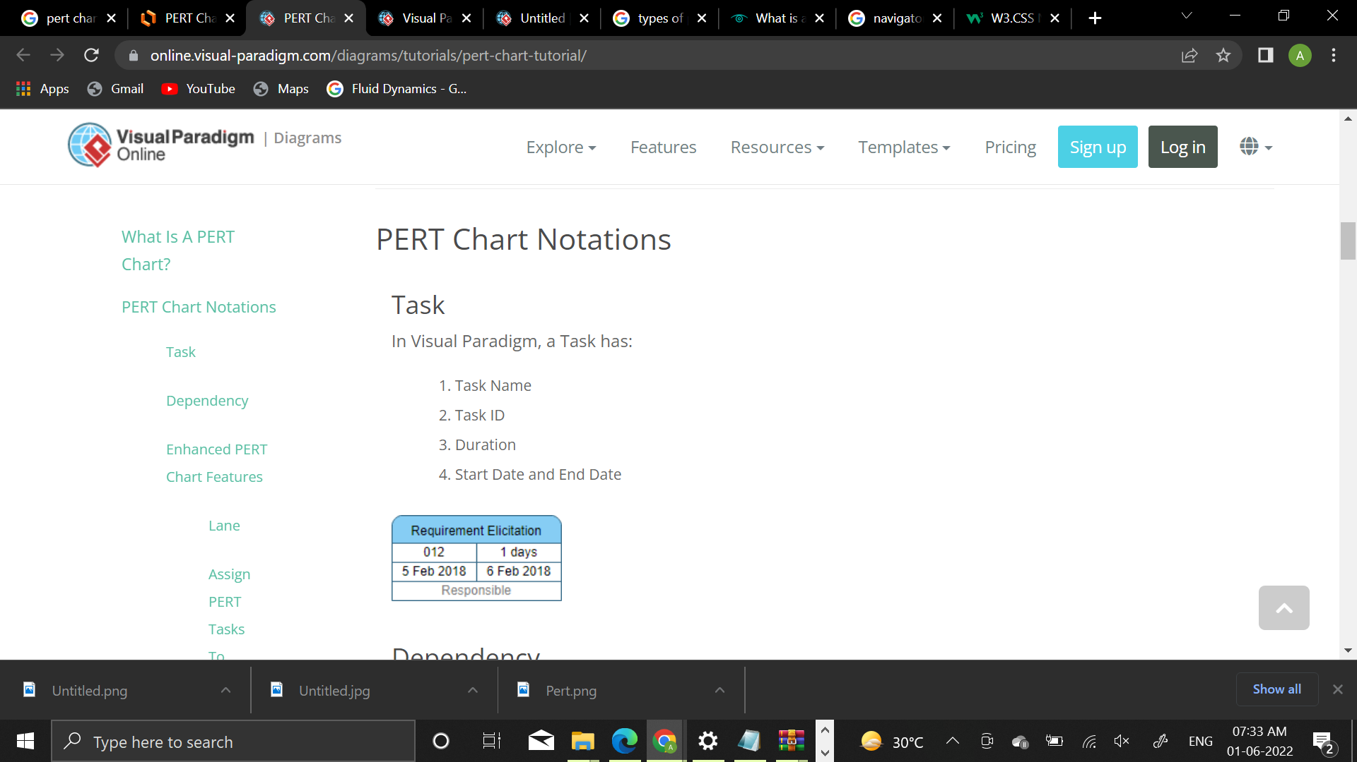

**DATA FLOW DIAGRAM SYMBOLS**

Symbol Purpose Symbol Purpose

Flow of control system

Start/Stop

Input/output

Annotation

Processing

Connector

Decision Box

**ENTITY-RELATIONSHIP DIAGRAM SYMBOLS**

LINK

RELATIONSHIP

ENTITY

ATRIBUTE

**WEBSITES**

* <https://www.w3schools.com>
* <https://www.lucidchart.com>
* <https://online.visual-paradigm.com>
* <https://script.google.com>
* <https://www.google.com/sheets>